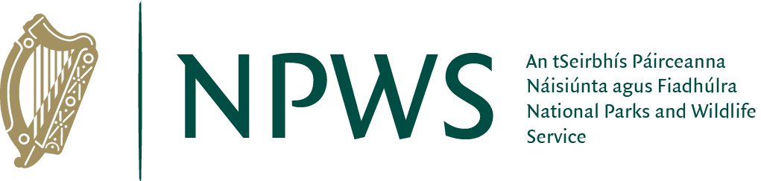

Permit Application

Proposed Event Information
Name of Organisation / Event:
Address of Organisation:

Contact person:

Contact person’s mobile phone & email: |  | Mobile: | Email:
Proposed Date(s) of Event:
Proposed duration: |  | Half day |  | Full day |  |  | Multi-day
Proposed location:
Event Description:

(Please provide as much
detail as possible, incl. proposed signage, vehicle access requested, catering, etc.)

Number of people/participants:
Environmental Impact Assessment submitted  (may not be needed for smaller events): |  |  |  |  | Yes | No
Public Liability insurance submitted: |  |  |  |  | Yes | No
Other landowners involved: |  |  |  |  | Yes | No
Other landowners’ permission granted: |  |  |  |  | Yes | No |  | N / A
Use of Drones / UAVs proposed? |  |  |  |  | Yes | No
I agree that exclusive use of location within the National Park is not possible: |  |  |  |  | Yes | No
Please indicate that you will comply with our stated policy of banning Single-use plastics: |  |  |  |  | Yes | No
‘Leave No Trace’ Policy in place?  (See www.lnt.org for more info) |  |  |  |  | Yes | No

Other information relevant to the application

